# 

**PERSONAL EXPENSE TRACKER**

**APPLICATION**

# A PROJECT REPORT

***Submitted by***

|  |  |
| --- | --- |
| **BHARATHI.B** | **(621719104005)** |
| **HARINI.G** | **(621719104013)** |
| **NANDHINI.R** | **(621719104026)** |
| **NAVANEETHAM.R** | **(621719104027)** |

***in partial fulfillment for the award of the degree of***

# BACHELOR OF ENGINEERING *in*

**COMPUTER SCIENCE AND ENGINEERING**

# MUTHAYAMMAL COLLEGE OF ENGINEERING,

**RASIPURAM.**

**ANNA UNIVERSITY :: CHENNAI 600 025**

# NOVEMBER 2022

|  |  |  |
| --- | --- | --- |
| **CHAPTER**  **NO** | **TABLE OF CONTENTS** | **PAGE**  **NO** |
|  | **INDEX** |  |
| **1** | **INTRODUCTION** |  |
|  | 1.1 Project Overview |  |
|  | 1.2 Purpose |  |
| **2** | **LITERATURE** **SURVEY** |  |
|  | 2.1 Existing problem |  |
|  | 2.2 References |  |
|  | 2.3 Problem Statement Definition |  |
| **3** | **IDEATION AND PROPOSED SOLUTION** |  |
|  | 3.1 Empathy Map Canvas |  |
|  | 3.2 Ideation and Brainstorming |  |
|  | 3.3 Proposed Solution |  |
|  | 3.4 Problem Solution fit |  |
| **4** | **REQUIREMENT ANALYSIS** |  |
|  | 4.1 Functional Requirement |  |
|  | 4.2 Non-Functional Requirements |  |
| **5** | **PROJECT DESIGN** |  |
|  | 5.1 Data Flow Diagrams |  |
|  | 5.2 Solution and Technical Architecture |  |
|  | 5.3 User Stories |  |
| **6** | **PROJECT PLANNING AND SCHEDULING** |  |
|  | 6.1 Sprint Planning and Estimation |  |
|  | 6.2 Sprint Delivery Schedule |  |
|  | 6.3 Reports from JIRA |  |
| **7** | **CODING AND SOLUTIONING** |  |
|  | 7.1 Feature 1 |  |
|  | 7.2 Feature 2 |  |
|  | 7.3 Database Schema |  |
| **8** | **TESTING** |  |
|  | 8.1 Test Cases |  |
|  | 8.2 User Acceptance Testing |  |
| **9** | **RESULTS** |  |
|  | 9.1 Performance Metrics |  |
| **10** | **ADVANTAGES**  **&**  **DISADVANTAGES** |  |
| **11** | **CONCLUSION** |  |
| **12** | **FUTURE SCOPE** |  |
| **13** | **APPINDIX** |  |
|  | Source Code |  |
|  | GitHub and Project Demo Link |  |

# INTRODUCTION

## PROJECT OVERVIEW:

A Personal Expense Tracker is a one kind of digital diary that helps to keep an eye on all of our money related transitions and also provides all financial activities report daily, weekly, monthly and yearly. Users get notification to record expenses and incomes that are helpful to the tracking system of the application. All information is saved in offline mode so users can easily access any time and any palaces. User interface of the personal Expense Tracker is very simple and attractive so it is easy to understand and the best way to record our financial data

## PURPOSE :

The motivation to work in this project is actually our real-life experience. As a user We face many difficulties in our daily file. In our daily life money is the most important portion and without it we cannot last one day on earth but if we keep on track all financial data then we can overcome this problem. Most of the people cannot track their expenses and income one way they face the money crisis and depression. This situation motivates us to make an android app to track all financial activities. Using the Daily Expense Tracker user can be tracking expenses day to day and making life tension free

# 2. LITERATURE SURVEY

## EXISTING PROBLEM:

You may be doing well in most fields of your budget, but there would be that one stubborn category that pulls you down every month. For some it may be shopping and for others it may be dining out. You have tried all you can, but haven’t been able to tame your spending in this category.

Another common problem a lot of people face is that they experience periods of financial famines and windfalls, depending on what time of the getBakers is based, the payday usually falls in the middle of the month. And, all the bills are scheduled towards the end of the month. So it is common that once you get paid and pay off your bills, a chunk of your pay vanishes in the first two weeks. In the next two weeks, it then becomes a battle for survival, when you struggle to even cover for your groceries. The only apparent solution to this then feels like the arrival of your paycheck.

## REFERENCES:

* + 1. Y. Anitha, R. Ranjini, S. Gomathi, “Easy App for Expanses Manager Using Android”, International Journals of Computer Techniques, Volume: 3 Issue: 2, ISSN: 2394-2231 (MarchApril 2016).

[2] N. ZahiraJahan MCA., M. Phil, K. I. Vinodhini, “Personalized Expense Managing Assistant Using Android”, International Journals of Computer Techniques (IJCT), Volume: 3 Issue: 2, ISSN: 2394-2231 (March-April 2016).

[3]P. Thanapal, Mohammed Yaseen Patel, T. P. Lokesh Raj and J. Satheesh Kumar, “Income and Expense Tracker”, Indian Journal of Science and Technology, Vol 8(S2), ISSN: 0974-5645 (January 2014).

[4]Girish Bekaroo and Sameer Sunhaloo, “Intelligent Online Budget

Tracker”, Computer Science and IT Education Conference(2014).

## PROBLEM STATEMENT :

Keeping track of expenses these days is not an easy job for people with busy lifestyle. Making sure each and every purchase is jotted is already a hassle but making sure the right outcome of savings after being deducted with expenses is even harder. Therefore, an easy solution for these issues is to find the right medium for users to maintain a better expense tracking diary.

This mobile application is proposed to help users overcome the struggles they have to endure when they do not track their expenses or track their expenses manually or even have troubles with the current existing expense tracker that they are using.

The common issues that occurs when users track their expenses

manually are that, they tend to overspend and users will not know where their money go which will consequently interfere with their future plans. But the problems with the existing applications are the fact that some are not user friendly, outdated and does not solves the users’ difficulties in planning their budget. When tracking expenses manually, users tend to miscalculate their expenses to the point that their cash ﬂow does not make sense. Therefore, this proposed project will help users solve these issues.

## 3.IDEATION AND PROPOSED SOLUTION

* 1. **EMPATHY MAP :**

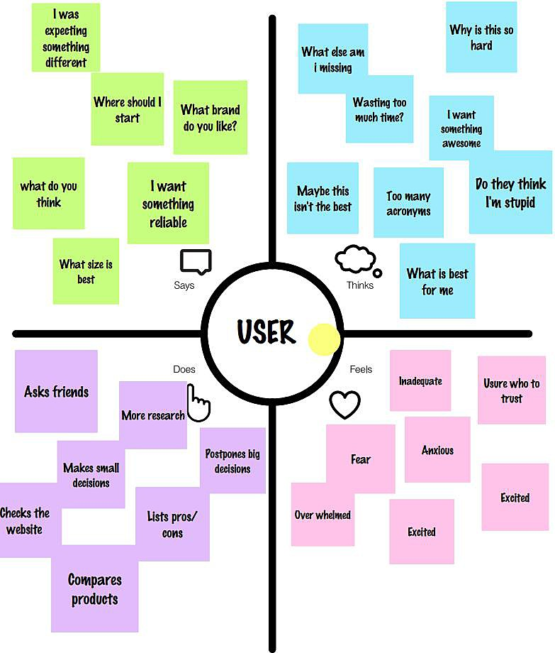

## IDEATION AND BRAINSTORMING :



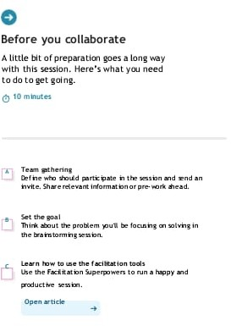

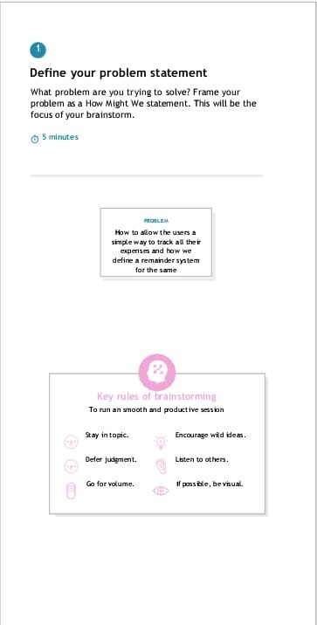

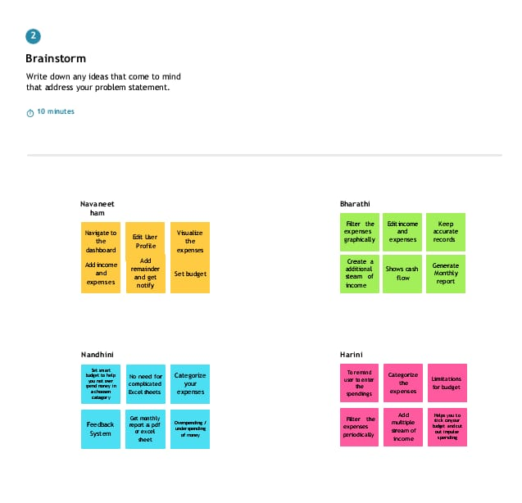

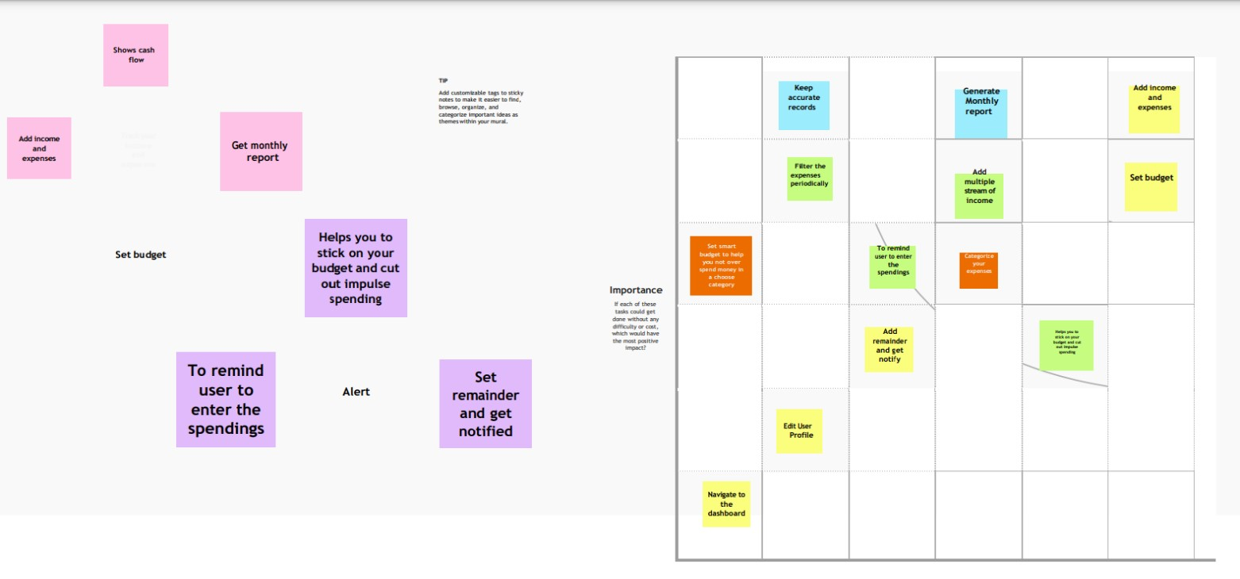

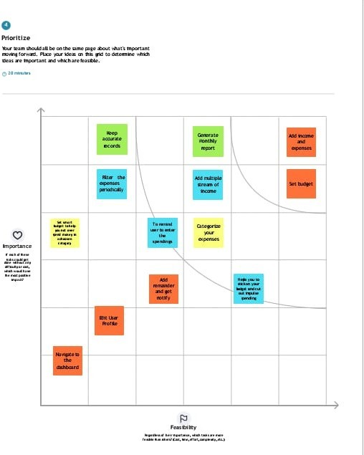

* 1. **PROPOSED SOLUTION:**

|  |  |  |
| --- | --- | --- |
| **S.**  **NO** | **Parameter** | **Description** |
| **1.** | Problem Statement (Problem to be solved) | In a Traditional Paper based expense tracking system, it is diﬃcult to track our monthly expenses manually. Some of the records may get lost in case of ﬁre, ﬂoods, etc. We are trying to solve this problem in a more  eﬃcient way. |
| **2.** | Idea / Solution description | This expense tracker is a computerize application which keeps track of all your ﬁnances and  helps in accounting and budgeting. |
| **3.** | Novelty / Uniqueness | The User gets notiﬁed once their expense touches 50% 75% 90% & 100% of their limits. Display the costs on a monthly and weekly basis in a  pie chart. |
| **4.** | Social Impact / Customer Satisfaction | This Application is able to generate reports of their spendings. It can create awareness among common people about ﬁnance. It makes users ﬁnancially responsible and satisfy  them without letting them to debt. |
| **5.** | Business Model (Revenue Model) | As this project is intended purely for educational purposes, we keep this application free of cost. |

**3.4 PROPOSED SOLUTION FIT:**

### CUSTOMER SEGMENT(S)

Be it a common man or a big ﬁsh, Our app comes in handy to all of those who wish to boost their expense potential. People who are unaware of ﬁnancial things of how to spend their money can make use of this app.

### JOBS-TO-BE-DONE/PROBLEMS

In a Traditional paper based expense tracking system, it is diﬃcult

to track our monthly expenses manually. Some of the records may get lost in case of ﬁre, ﬂoods, etc..,

### TRIGGERS

This application can create awareness among common people about their income and expenses. It reduces time rather than entering details manually.

### EMOTIONS: BEFORE/AFTER

Frustration, confusion, rage / Feeling smart, leading happy life, being an example for others.

### AVAILABLE SOLUTIONS

User can add their income and expenses. They have an option to set a limit on how much they can spend on their salary or savings. IF that particular limit is exceeded they are notiﬁed by email.

### CUSTOMER CONSTRAINTS

User have to entry record manually, sometimes while maintaining a large amount of data may look messy. User who is maintaining the system must have some technical knowledge

### BEHAVIOUR

People may be notes on their mobile. They try to remember the expenses they do and calculate the whole expense at once at the end of the month which may take a long time to calculate.

### 8.CHANNELS OF BEHAVIOUR

**ONLINE:**

People may use online tools to calculate their expenses

**OFFLINE:**

People may use a ledger to calculate their expenses

# 4.REQUIREMENT ANALYSIS

## FUNCTIONAL REQUIREMENTS:

* Size of the application.
* The complexity of the app.
* Features to be incorporated.
* UX/UI design.
* Testing.
* Location.
* Third-party integrations.

## NON-FUNCTIONAL REQUIREMENTS:

### Security Requirements:

1. Passwords shall be displayed as “*” in the web pages wherever required.
2. Proper authentication is required for users to access any of the web pages including the home page.
3. Every user of the system is assigned a unique login and password to access the application over the interne
4. Microsoft .NET framework ensures security of data, for example passwords that are being transmitted over the internet

### SYSTEM CONSTRAINTS:

This application is developed to be ﬂexible enough to work on any system and independent of the type of web browser used. The only constraint is the client will need a web-enabled system with web browser.

### SOFTWARE QUALITY ATTRIBUTES:

Reliability this project is one of the most critical attributes as it involve the ﬁnancial aspect of the employee. The employee expense i.e., the data entered must always be correctly stored into the database. In addition, the database should commit transactions so that partial entries are not stored in the database. Usability The system should be very easy to use with minimal required training. Individuals of varying skill level and technical competence will use the system. Maintainability The code and design need to be documented well enough and designed such that a new project member with the same amount of academic and co-op experience can easily ramp up the project.

# 5.PROJECT DESIGN

## 5.1. DATA FLOW DIAGARAMS:

A Data Flow Diagram (DFD) is a traditional visual representation of the information ﬂows within a system. A neat and clear DFD can depict the right amount of the system requirement graphically. It shows how data enters and leaves the system, what changes the information, and where data is stored.

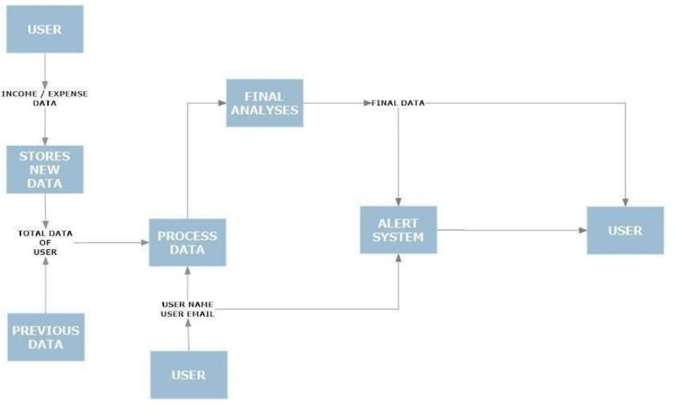

**5.2 SOLUTIONS & TECHNICAL ARCHITECTURE:**

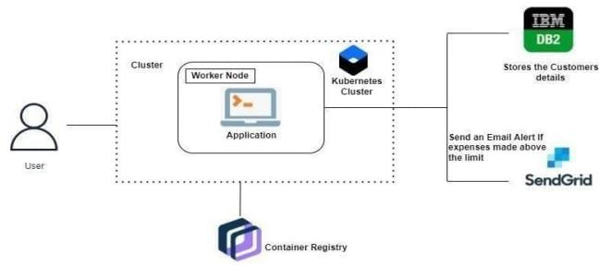

## 5.3. USER STORIES:

|  |  |  |  |  |  |  |
| --- | --- | --- | --- | --- | --- | --- |
| **User type** | **Functional Requirements(Epic)** | **User Story Number** | **User story/task** | **acceptance criteria** | **priority** | **Release** |
| Customer (application & web user) | Registration | USN-1 | As a user, I can register for the application by entering my  email,  password, and conforming my password. | I can access my account/ dashboard | High |  |
|  |  | USN-2 | As a user , I will receive conﬁrmation email once I have  registered for  the application. | I can receive conﬁrmation email & click conﬁrm | High |  |
|  |  | USN-3 | As a user, I can register for the application  through  Facebook | I can register & access the dashboard with Facebook  login | Low |  |
|  | Login | USN-4 | As a user, I can log into the application by entering email  &password | I can access  the application | High |  |
|  | Dashboard | USN-5 | As a user I can enter my income and  expenditure  details. | I can view my daily expense | High |  |
| Customer Care Executive |  | USN-6 | As a customer care executive I can solve the log in issues and other issues of the  application. | I can provide support or solution at any time 24*7 | Medium |  |

**6.PROJECT PLANNING AND SCHEDULING**

**6.1 Sprint Planning And Estimation :**

|  |  |  |  |  |  |  |
| --- | --- | --- | --- | --- | --- | --- |
| **Sprint** | **Functional Requirements(Epic)** | **User Story Numb er** | **User Story / Task** | **Story points** | **Priori ty** | **Team Members** |
| Sprint-1 | Registration | PET- 1 | As a user, I can register for the application by entering my email, password, and confirming my password. | 10 | High | NAVANEETHAM |
| Sprint-1 | Login | PET- 2 | As a user, I can login to user dashboard and see the information about my incomes and expenses. | 10 | High | NAVANEETHAM |
| Sprint-2 | Dashboard | PET- 3 | As a user, I can enter my income and expenditure details. | 20 | High | BHARATHI |

|  |  |  |  |  |  |  |
| --- | --- | --- | --- | --- | --- | --- |
| **Sprint** | **Functional**  **Requirements**  **(Epic)** | **User**  **Story**  **Numb er** | **User Story / Task** | **Story Points** | **Priority** | **Team Members** |
| Sprint-3 | Expense Update | PET- 4 | As a user ,I can track my expenses and manage my monthly budget. | 10 | High | NANDHINI |
| Sprint-3 | Email Alert | PET- 5 | As a user, I can see if there is an excessive expense and if there is such condition, I will be notiﬁed via e-mail. | 10 | Medium | HARINI |

|  |  |  |  |  |  |  |
| --- | --- | --- | --- | --- | --- | --- |
| **SPRINTS** | **TOTAL STORY**  **POINTS** | **DURATION** | **SPRINT START DATE** | **SPRN**  **END DATE** | **STORY**  **POINTS**  **COMPLETE** | **SPRINT RELEASE DATE** |
| SPRINT – 1 | 20 | 6 Days | 3 NOV  2022 | 8 NOV  2022 | 20 | 8 NOV 2022 |
| SPRINT – 2 | 20 | 6 Days | 4 NOV  2022 | 9 Nov  2022 | 20 | 9 Nov 2022 |
| SPRINT – 3 | 20 | 6 Days | 4 NOV  2022 | 9 Nov  2022 | 20 | 9 Nov 2022 |
| SPRINT – 4 | 20 | 6 Days | 5 Nov  2022 | 10 Nov  2022 | 20 | 10 Nov 2022 |

Average Velocity = 20 / 6 = **3.**

**SPRINT DELIVERY SCHEDULE :**

|  |  |  |  |  |  |  |
| --- | --- | --- | --- | --- | --- | --- |
| **Sprint** | **Total Story**  **Point** | **Duration** | **Sprint Start**  **Date** | **Sprint End**  **Date**  **(Planned)** | **Story point completed**  **(As on planned end date)** | **Sprint Release**  **Date(actual)** |
| Sprint 1 | 20 | 6 days | 23 Oct 2022 | 27 Oct 2022 | 20 | 28 Oct 2022 |
| Sprint2 | 20 | 6 days | 30 Oct 2022 | 2 Nov 2022 | 20 | 03 Nov 2022 |
| Sprint 3 | 20 | 6 days | 6 Nov 2022 | 10 Nov 2022 | 20 | 11 Nov 2022 |
| Sprint 4 | 20 | 6 days | 13 Nov 2022 | 18 Nov 2022 | 20 | 19 Nov 2022 |

**Velocity**

We have a 6-day sprint duration, and the velocity of the team is 20 (points per sprint). Calculating the team’s average velocity (AV) per iteration unit (story points per day)

AV = sprint duration / velocity = 20/6 = 3.33

**Burndown Chart:**

A burn down chart is a graphical representation of work left to do versus time. It is often used in agile software development methodologies such as Scrum. However, burn down charts can be applied to any project containing measurable progress over time.

**6.3 REPORTS FROM JIRA:**

**JIRA REPORT 1:**

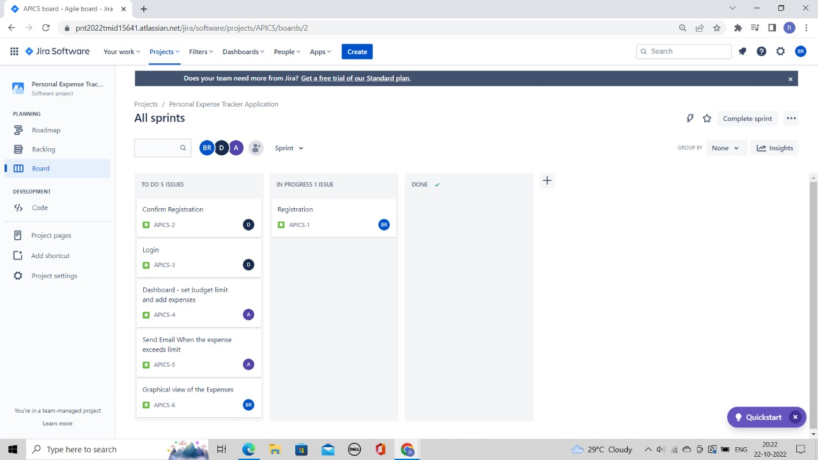

**JIRA REPORT 2 :**

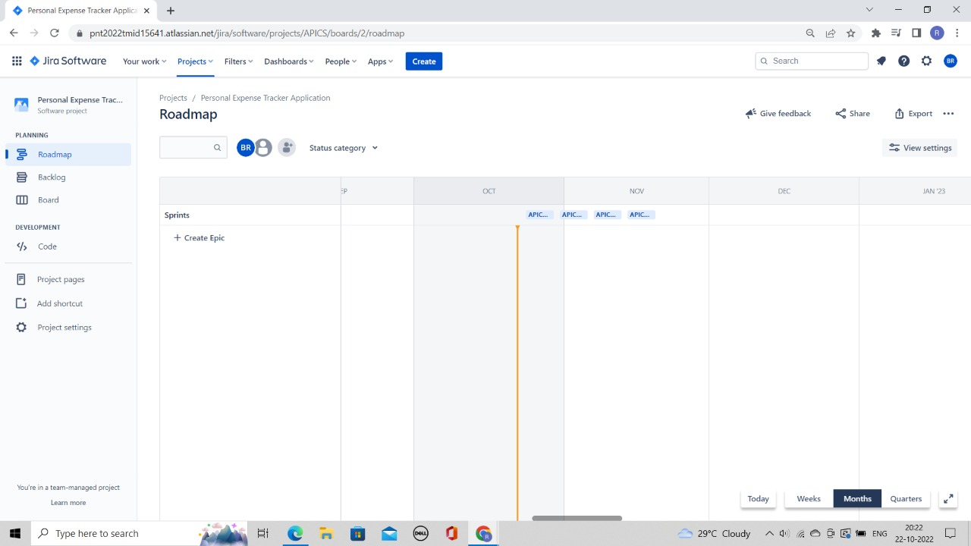

**JIRA REPORT 3 :**

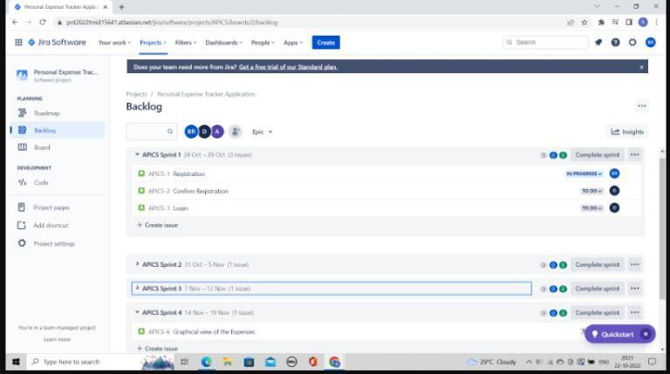

**8.TESTING**

**8.1 Test Cases**

|  |  |  |  |  |
| --- | --- | --- | --- | --- |
| Test case ID | Feature Type | Component | Test Scenario | Pre-Requisite |
| LoginPage_TC_O01 | Functional | Home Page | Verify user is able to see t e Login/Signup popup when user clicked on My account button | None |
| LoginPage_TC_O02 | UI | Home Page | Verify the UI elements in Login/Signup popup | Home |
| LoginPage_TC_O03 | Functional | Home page | Verify user is able to log into application with Valid credentials | Username & password |
| LoginPage_TC_O04 | Functional | Login page | Verify user is able to log into application with Invalid credentials | Username & password |
| LoginPage_TC_O04 | Functional | Login page | Verify user is able to log into application with Invalid credentials | Login first |
| LoginPage_TC_O05 | Functional | Login page | Verify user is able to log into application with Invalid  credentials | Login first |
| Add Expense  Page_OO5_TC | Functional | Add  Expense page | Verify whether user is able to add expense or not | Have some expense to add |

|  |  |  |  |  |  |  |  |  |
| --- | --- | --- | --- | --- | --- | --- | --- | --- |
| Steps To Execute | Test Data | Expected Result | Actual Result | Status | Comment | TC for Auto | BUG ID | Executed By |
| 1. Go to website 2.Home page appears | Username: test password: 123456 | Login/Signup popup should display | Working as  expected | Pass | - |  |  | PRAVEEN KUMAR |
| 1. Go to website 2. Enter details and click login | Username: test password: 123456 | Application should show below UI elements:  A .email text box B. password text box  C. Login button with orange color  D. New customer? Create account link  E. Last password? Recovery pass  link | Working as  expected | Pass | - |  |  | BHARATHVAJ |
| 1. Go to website 2. Enter details and click login | Username: test password: 123456 | User should navigate to user account homepage | Working as  expected | Pass | - |  |  | DEEPAK RAJ |
| 1. Go to website 2. Enter details and click login | Username: test password: 123456 | Application should show 'Incorrect mail or password ' validation message. | Working as  expected | Pass | - |  |  | SRIDHARAN |
| 1. Go to website 2. Enter details and click login | Username: test password: 123456 | Application should show 'Incorrect email or password ' validation message. | Working as  expected | Pass | - |  |  | PRAVEEN KUMAR |
| 1. Go to website 2. Enter details and click login | Username: test password: 123456 | Application should show 'Incorrect email or password ' validation message. | Working as  expected | Pass | - |  |  | DEEPAK RAJ |
| 1. Add date, expense name and other details . 2. Check if the expense gets added | add rent = 6000 | Application adds expenses | Working as  expected | Pass | - |  |  | SRIDHARAN |

* 1. **USER ACCEPTANCE TESTING**

# Purpose of Document

The purpose of this document is to briefly explain the test coverage and open issues of the Personal Expense Tracker Application project at the time of the release to User Acceptance Testing (UAT).

# Defect Analysis

This report shows the number of resolved or closed bugs at each severity level, and how they were resolved

|  |  |  |  |  |  |
| --- | --- | --- | --- | --- | --- |
| **Resolution** | **Severity 1** | **Severity 2** | **Severity 3** | **Severity 4** | **Subtotal** |
| By Design | 10 | 5 | 2 | 3 | 20 |
| Duplicate | 1 | 0 | 3 | 0 | 4 |
| External | 2 | 3 | 0 | 1 | 6 |
| Fixed | 11 | 2 | 4 | 20 | 37 |
| Not Reproduced | 0 | 0 | 0 | 0 | 0 |
| Skipped | 0 | 0 | 0 | 0 | 0 |
| Won't Fix | 0 | 5 | 2 | 1 | 8 |
| Totals | 24 | 14 | 13 | 26 | 75 |

# Test Case Analysis

This report shows the number of test cases that have passed, failed, and untested

|  |  |  |  |  |
| --- | --- | --- | --- | --- |
| **Section** | **Total Cases** | **Not Tested** | **Fail** | **Pass** |
| Print Engine | 7 | 0 | 0 | 7 |
| Client Application | 29 | 0 | 0 | 29 |
| Security | 4 | 0 | 0 | 4 |

|  |  |  |  |  |
| --- | --- | --- | --- | --- |
| Outsource Shipping | 6 | 0 | 0 | 6 |
| Exception Reporting | 7 | 0 | 0 | 2 |
| Final Report Output | 5 | 0 | 0 | 5 |
| Version Control | 1 | 0 | 0 | 1 |

**9.RESULTS**

**9.1 PERFORMANCE METRICS**

The performance of a recommendation algorithm is evaluated by using some specific metrics that indicate the accuracy of the system. The type of metric used depends on the type of filtering technique. Root Mean Square Error (RMSE), Receiver Operating Characteristics (ROC), Area Under Cover (AUC), Precision, Recall and F1 score is generally used to evaluate the performance or accuracy of the recommendation algorithms.

Root-mean square error (RMSE). RMSE is widely used in evaluating and comparing the performance of a recommendation system model compared to other models. A lower RMSE value indicates higher performance by the recommendation model. RMSE, can be as represented as follows:

**1.Precision**

Precision can be defined as the fraction of correct recommendations or predictions (known as True Positive) to the total number of recommendations provided, which can be as represented as follows:

It is also defined as the ratio of the number of relevant recommended items to the number of recommended items expressed as percentages.

**2.Recall**

Recall can be defined as the fraction of correct recommendations or predictions (known as True Positive) to the total number of correct relevant recommendations provided, which can be as represented as follows:

It is also defined as the ratio of the number of relevant recommended items to the total number of relevant items expressed as percentages.

**3.F1 Score**

F1 score is an indicator of the accuracy of the model and ranges from 0 to 1, where a value close to 1 represents higher recommendation or prediction accuracy. It represents precision and recall as a single metric and can be as represented as follows:

**4.Coverage**

Coverage is used to measure the percentage of items which are recommended by the algorithm among all of the items.

**5.Accuracy**

Accuracy can be defined as the ratio of the number of total correct recommendations to the total recommendations provided, which can be as represented as follows:

**10.ADVANTAGES &DISADVANTAGES:**

**10.1. ADVANTAGES:**

* It Helps You Stick to Your Budget.
* Tracking Your Expenses Can Reveal Spending Issues.
* It Helps You Meet Your Financial Objectives.
* Record Expenses With Pen and Paper.
* Make It Easier With an App or Software.
* Work Together as a Couple.

It’s simple to set up and use. When you’re creating your own method of tracking your finances, you first have to figure out how you’re going to do that. Are you going to use pen and paper, or software, or an excel spreadsheet? What are you going to track? How are you going to input that data, and how often are you going to do it? With an automated app, it tracks everything for you in real time. It has a wealth of information, so no matter what data you feel is important to track, it is all there and available for you – you just need to take a look to see it. There’s an easy user interface for everything as well. Whether you want to [set up a budget](https://maplemoney.com/control-your-spending-with-a-budget/), track a type of expense, or look over your financial history, there’s a tab or an option ready and waiting for you.

**10.2. DISADVANTAGES:**

* A con with any system used to track spending is that one may start doing it then taper off until it's forgotten about all together.
* Yet, this is a risk for any new goal such as trying to lose weight or quit smoking.
* If a person first makes a budget plan, then places money in savings before spending any each new pay period or month, the tracking goal can help.
* In this way, tracking spending and making sure all receipts are accounted for only needs to be done once or twice a month.

**11.CONCLUSION**

Monitoring your everyday expenses can set aside you cash, yet it can likewise help you set your monetary objectives for what’s to come. On the off chance that you know precisely where your sum is going much of a stretch see where a few reductions and bargains can be made. Expense Tracker project is for keeping our day-to-day expenditures will helps us to keep record of our money daily. The project what we have created is wOrk more proficient than the other income andexpense tracker. The project effectively keeps away from the manual figuring for trying not to ascertain the pay and cost each month. It’s a user-friendly application.

**12.FUTURE SCOPE**

**1**) It will have various options to keep record (for example Food, Travelling Fuel, Salary etc.).

**2)** Automatically it will keep on sending notifications for our daily expenditure.

**3)** In today’s busy and expensive life, we are in a great rush to make moneys, but at the end of the month we broke off. As we are unknowingly spending

money on title and unwanted things. So, we have come over with the plan to follow our profit.

**4)** Here user can define their own categories for expense type like food, clothing, rent and bills where they have to enter the money that has been spend and likewise can add some data in extra data to indicate the expense.

**13.APPENDIX**

**SOURCE CODE**

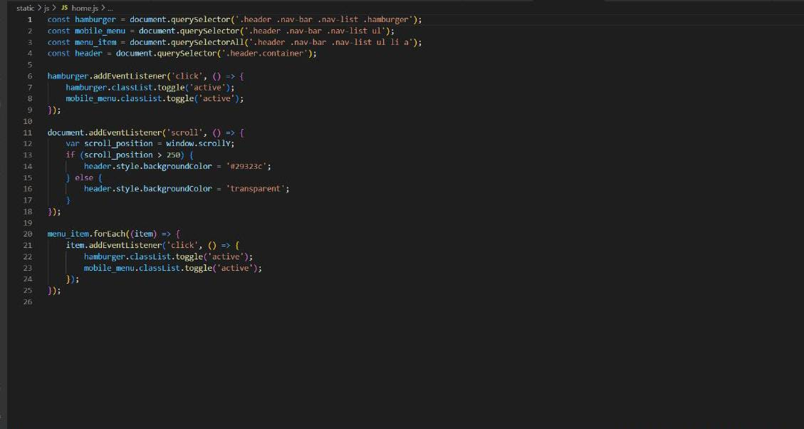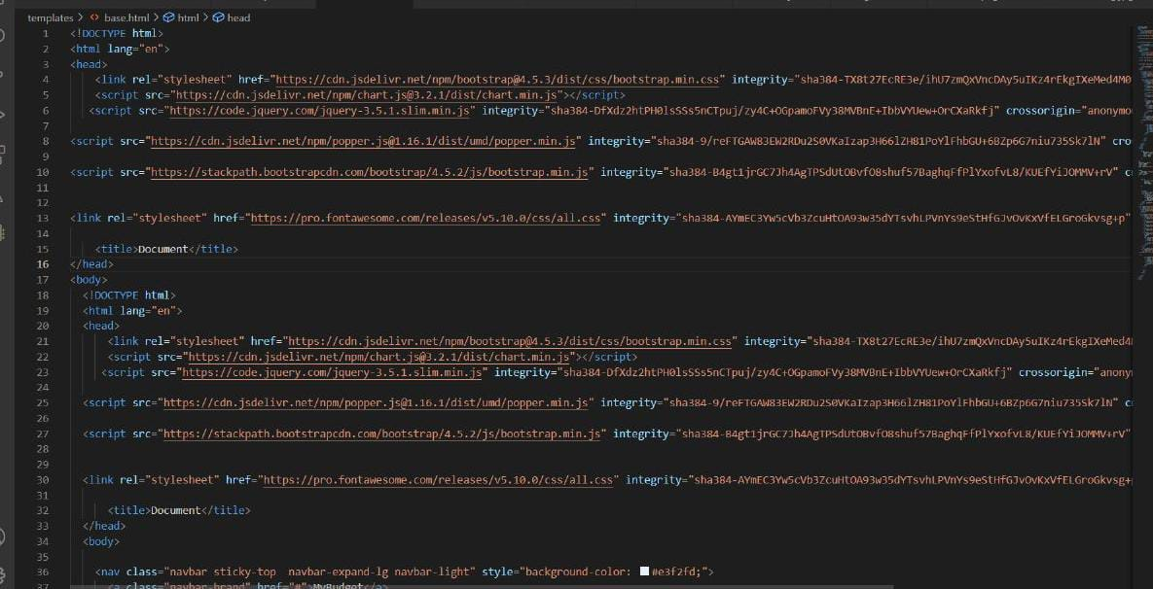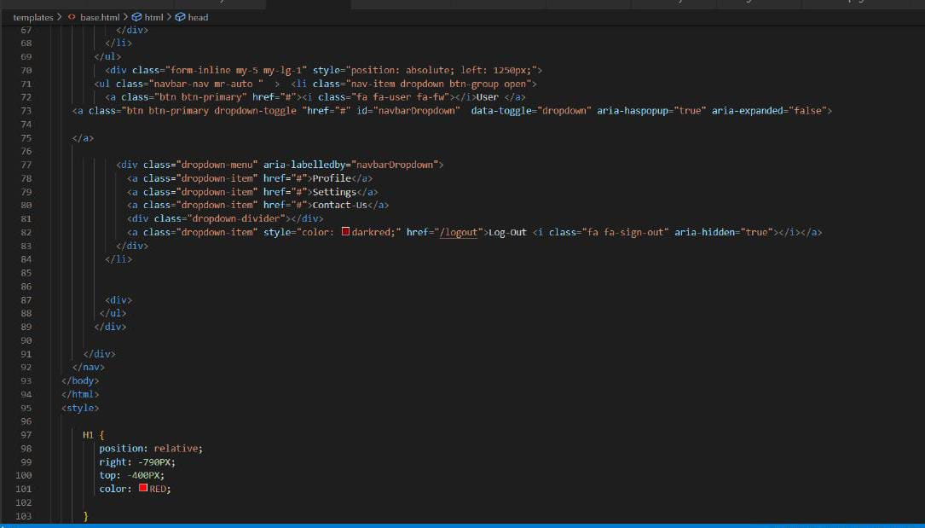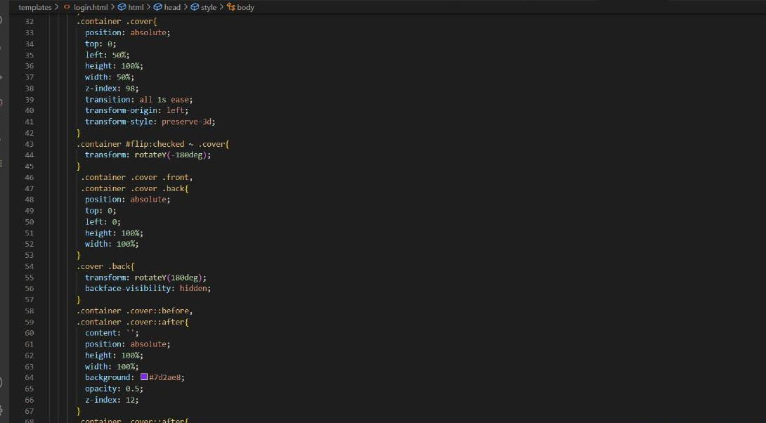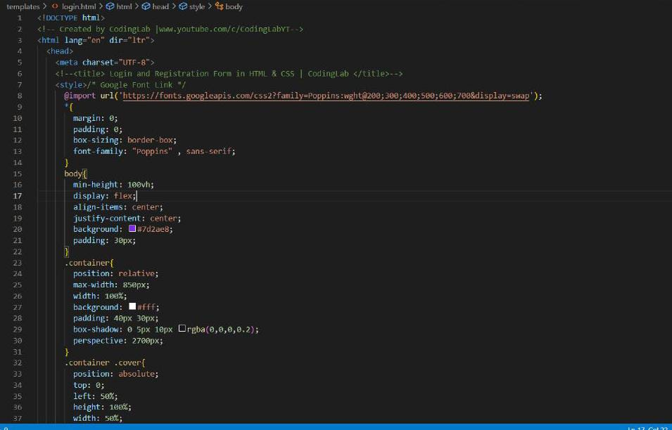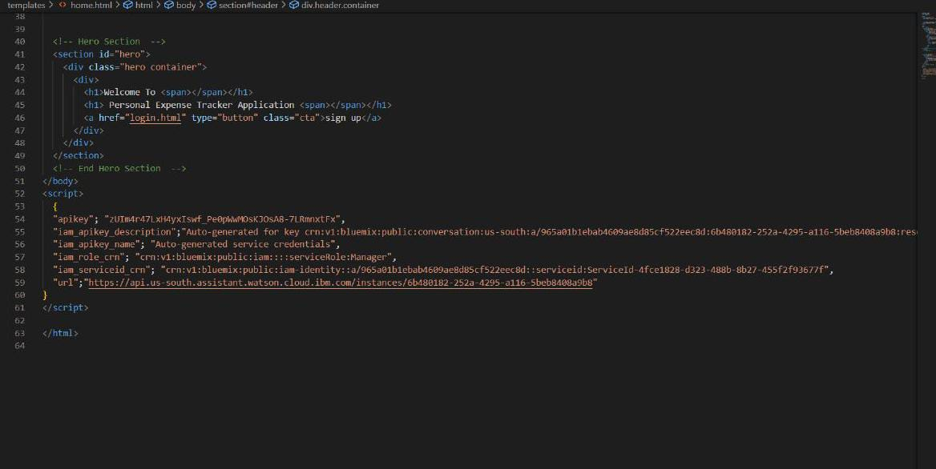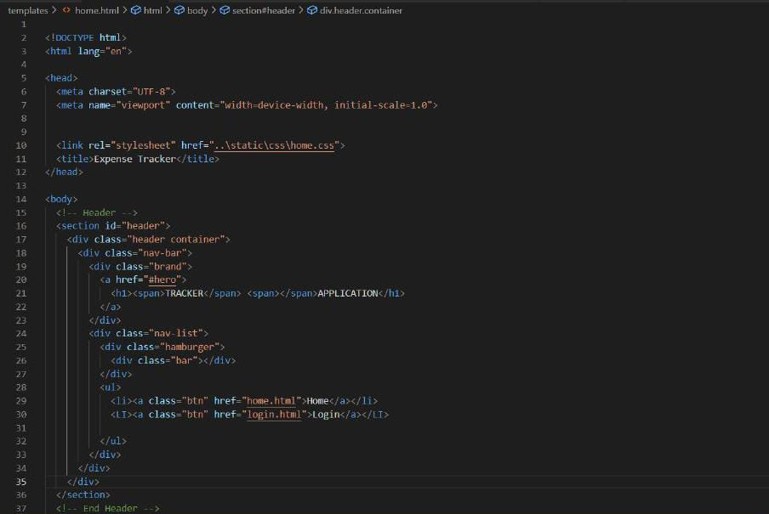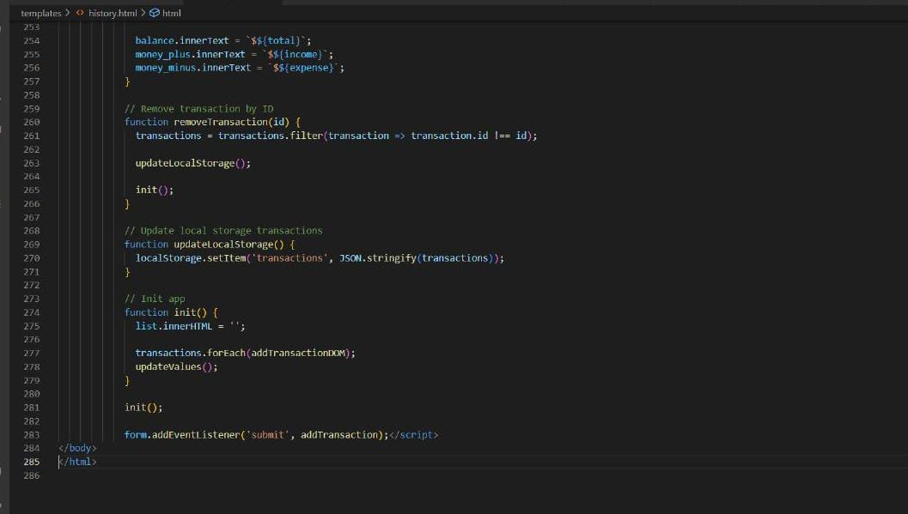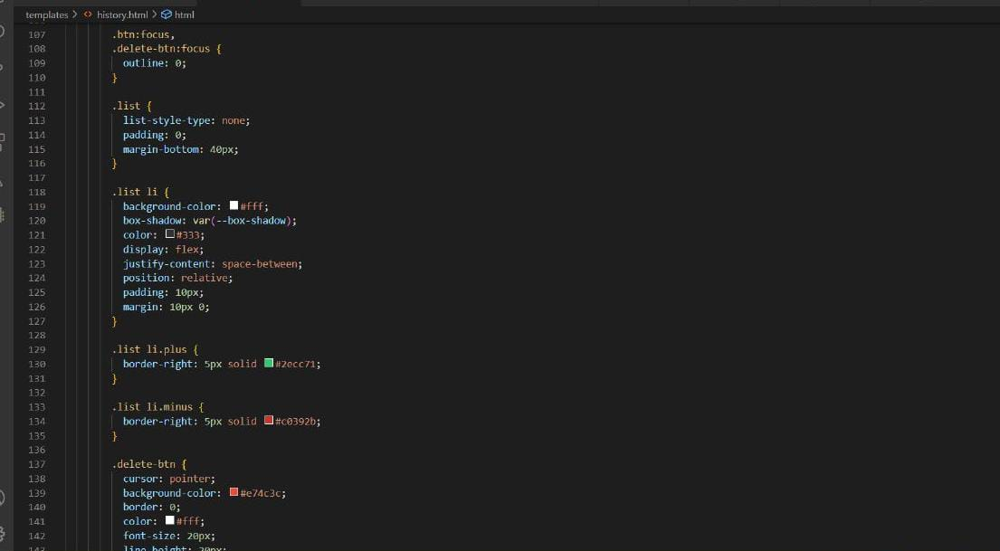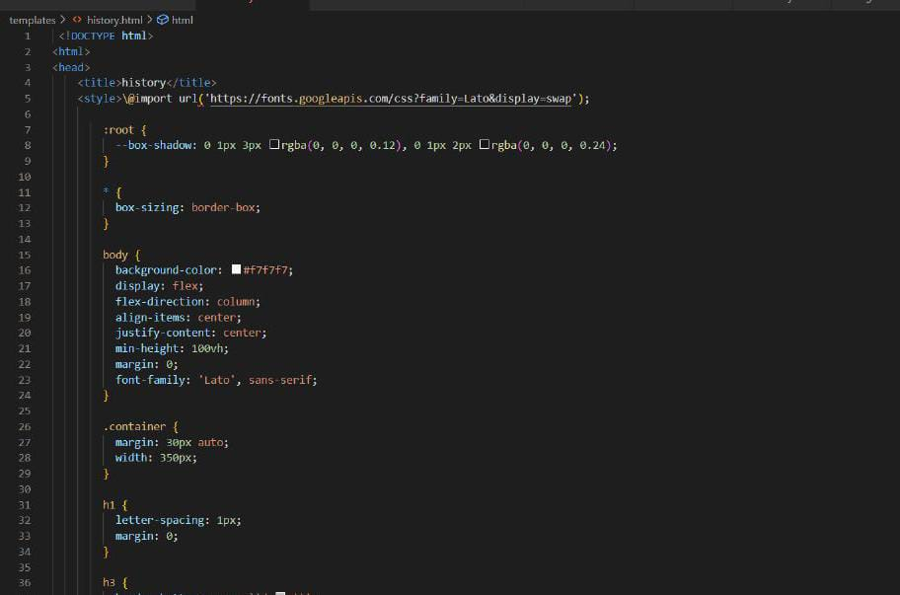

**OUTPUT**

**HOME PAGE**

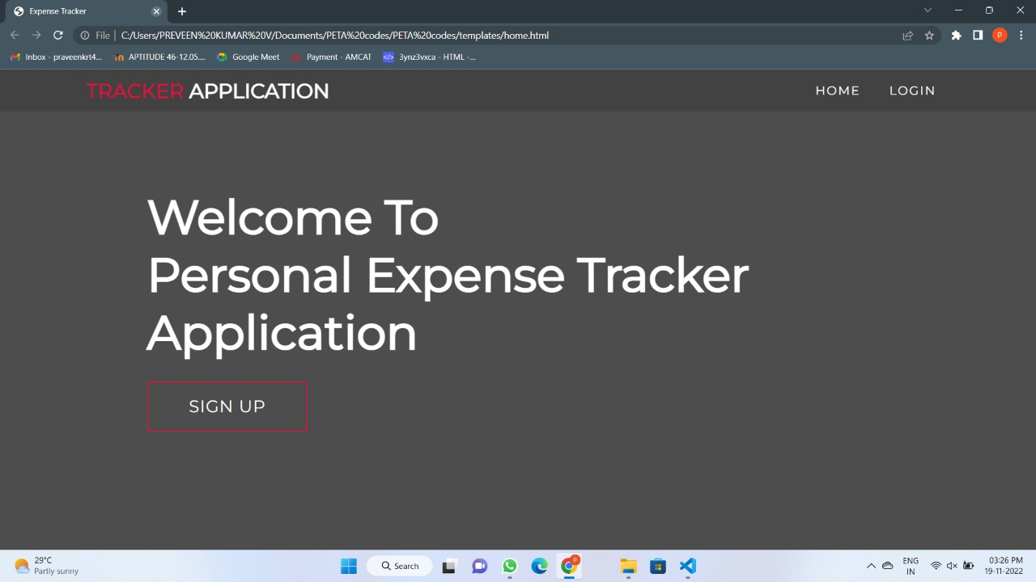

**LOGIN PAGE**

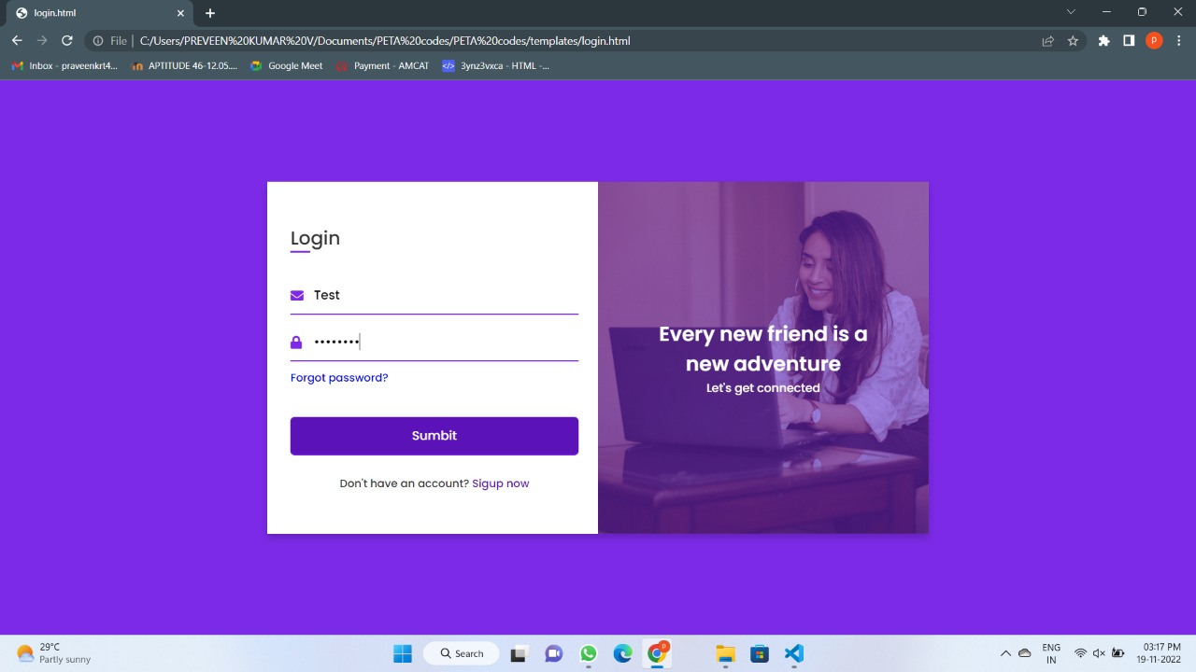

**DASHBOARD**

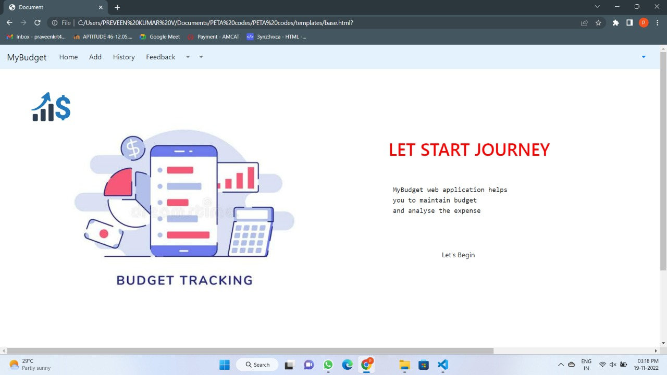

**EXPENSE TRACKER**

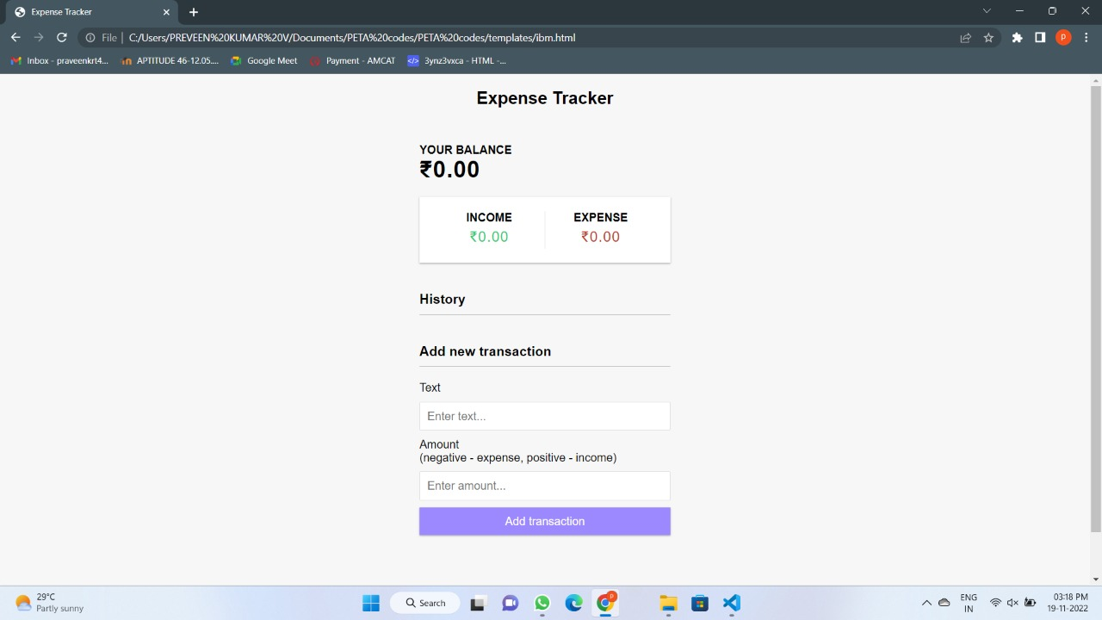

**GITHUB**: [IBM-EPBL](https://github.com/IBM-EPBL)/[**IBM-Project-23450-1659883465**](https://github.com/IBM-EPBL/IBM-Project-23450-1659883465)

**TEAM ID**: PNT2022TMID41626